CEREAL FOOD

Look at the picture!

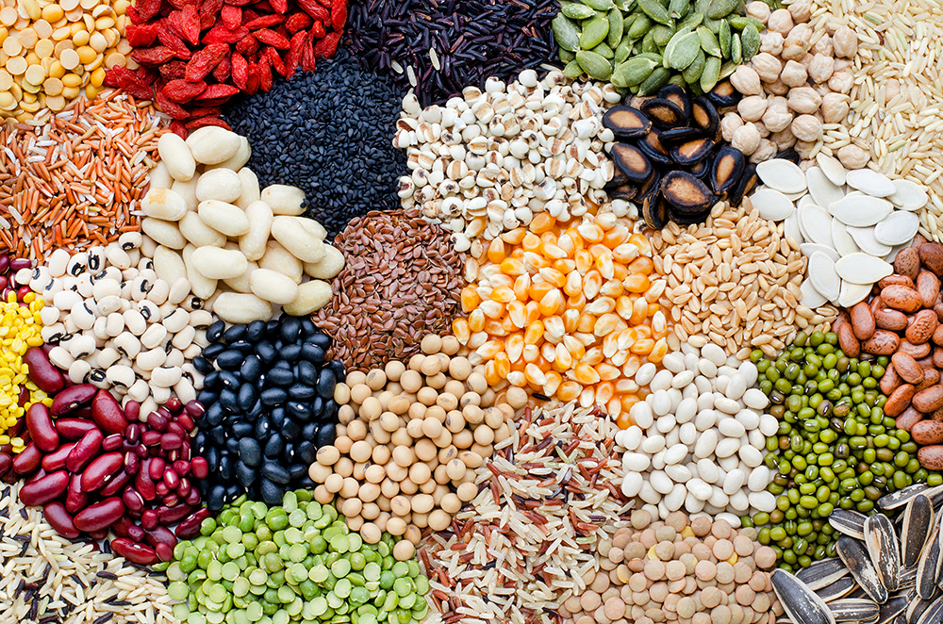

How many of the cereals can you recognize?

soybean; rice; goji berry; sesame, pumpkin, watermelon, sunflower seed; black eye pea; mung, flax seed; corn; pinto; chickpea; black, green and red bean seed; brown, green, yellow lentil

