Ancient monsters

1. The sirens | a.  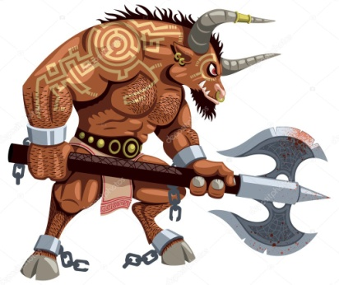 | b.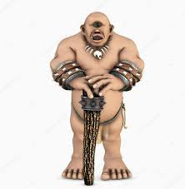 | - a six headed serpent
2. Lamia |  |  | - a monster with  snakes on its head
3. Chimera | c.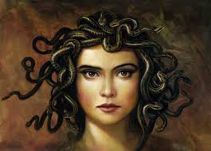 | d.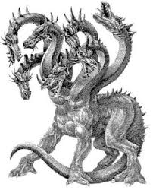 | - a dog with three heads
4. Cerberus |  |  | - a monster with a lion’s head  a goat’s body and feet and  bird’s wings
5. The harpies | e.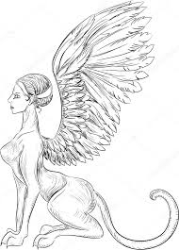 | f.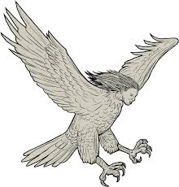 | - a woman’s head, a lion’s  body and feet and bird’s wings
6. The Sphinx |  |  | - half-man, half-bull
7. Scylla | g.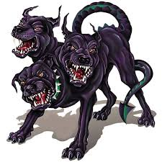 | h.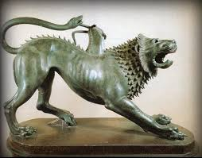 | - half woman, half -eagle
8. Cyclops |  |  | - half-woman, half-fish
9. Medusa | i.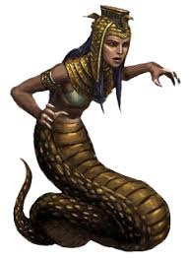 | j.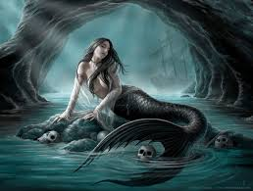 | - a one- eyed giant
10. The Minotaur |  |  | - half-woman, half snakes

Megfejtés: 1jH, 2iJ, 3hD, 4gC, 5fG, 6eE, 7dA,8bI, 9cB, 10aF

Készítette: Ráczné Pincési Julianna

