ANTS

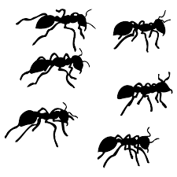
Ants are insects.
They have a large head, two big eyes, strong jaws and long feelers.
They have six legs. The body is in two parts: the thorax where the legs join, and the abdomen.
The ant colony has three different types of ant: the queen, the males and the workers.
The most important ant in the nest is the queen.
The nest is built by the worker ants. It is usually underground. There are lots of tunnels in the nest. They lead into chambers.

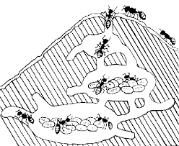
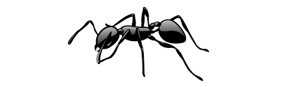
Jaws
Nest
Larvae
Chamber
Tunnel

Label parts of the ant.
3. ___________________
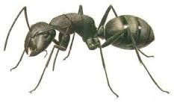
2. ___________________
4._________________

5. ______________

1. ___________

Word Find:
A | N | T | R | M | G | K | L | T | H
L | C | R | A | F | E | E | L | E | R
J | A | W | S | T | L | E | G | S | J
W | O | R | K | E | R | E | E | C | D
Q | U | E | E | N | P | G | E | B | Q
Y | T | H | I | W | H | E | H | F | I

ANT, WORKER, FEELER, EGGS, JAWS, LEGS, QUEEN
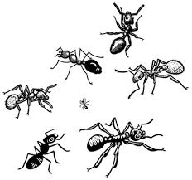

T
The queen lays lots of eggs.
Most are workers, some are males, and a few will be new queens.

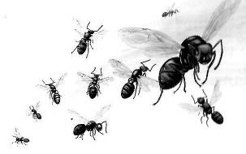
All worker ants are females.
They do not have wings and cannot lay eggs.
Worker ants look after the nest and find food.
They look after the eggs and feed the larvae.
They care for the cocoons until the new ants are ready to come out.

Male ants have wings.
They usually hide in the nest.
Sometimes they follow a new queen who flies off to start a new ant colony.
Flying ants
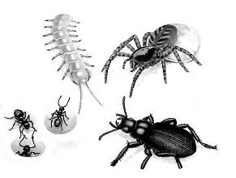
Ants are often attacked and eaten by
spiders, beetles and centipedes.
centipede
spider
Ants have strong jaws to bite and
they can sting with acid.
Soldier ants are big worker ants with
very large jaws.
beetle

Fill the gaps with the correct word:
feelers, jaws. insects, nest, feelers, wings, eggs

1. Ants are _______________________________
2. Ants live in a____________________________
3. The queen lays __________________________
4. Male ants have __________________________
5. Ants taste and smell with __________________
6. Ants bite with ___________________________
7. Ants have six ___________________________
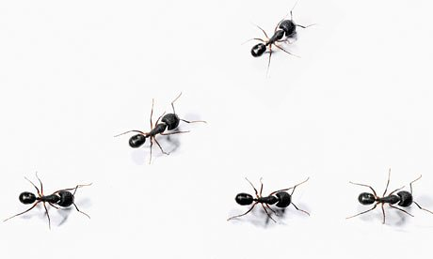
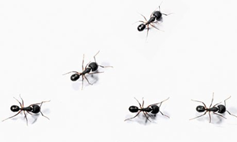
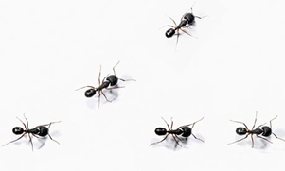

Ant Jokes:
What is the biggest ant in the world? An elephant
What ant is even bigger than an elephant? A giant
What is smaller than an ant's dinner? An ant's mouth!
What’s smaller than ants’ pants? Bees’ knees
What do you call a very old ant? An antique
What do you call a smartly dressed ant? Elegant!
What medicine would you give a sick ant? Antibiotics!
What do you call an ant that skips school? A truant!
